For List of test environment users, see <https://docs.google.com/spreadsheets/d/130xwXi1y-zsGiO_N-T9zvONtSZ9lw1tiEFP1UUSABjo/edit?usp=sharing>

For list of test environment sessions, see <https://docs.google.com/spreadsheets/d/1D3Yo8oNHWtY3qCpRryKT0nwVvUSM-WTCx3GzjEkuCsw/edit?usp=sharing>

### 

### Login as Instructor

1. In an incognito window, go to URL <http://localhost:4200/session/upcoming?forceTime=2020-12-09T18:15:00.000Z>  
     
   Notice that you may have to change the value of forceTime to match your when the session assigned to you is scheduled (see <https://docs.google.com/spreadsheets/d/1D3Yo8oNHWtY3qCpRryKT0nwVvUSM-WTCx3GzjEkuCsw/edit?usp=sharing> or get a value from another developer)
2. If prompted to login, login as the instructor assigned to you, use password: togethernow
3. The landing page for the instructor looks like this:  
   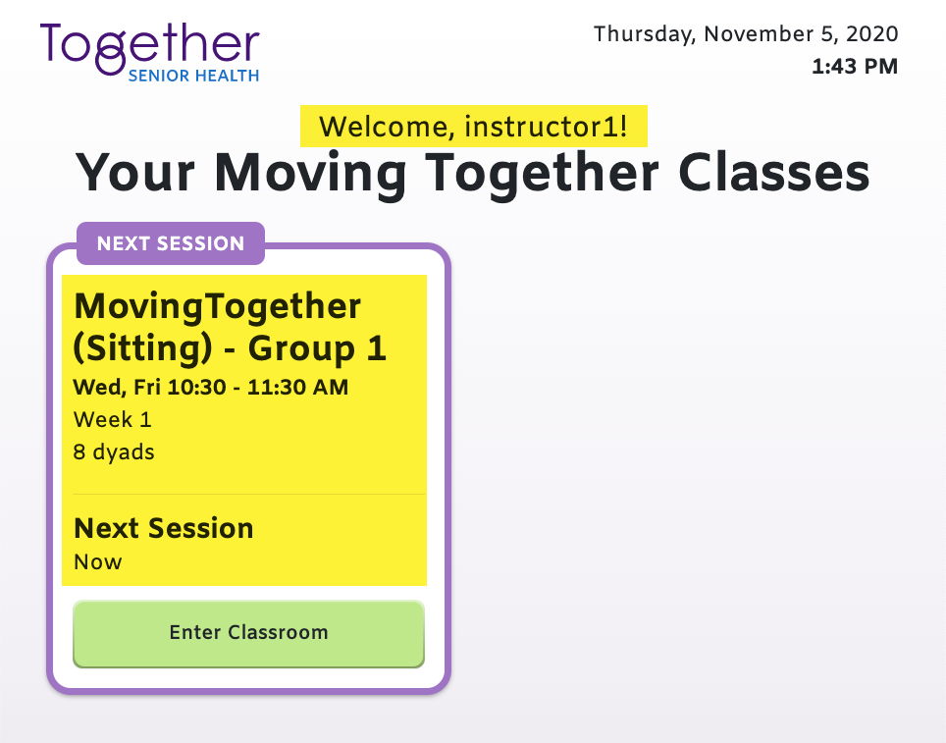
4. Notice instructor name and class name. Click “Enter Classroom”
5. The page should look something like this:

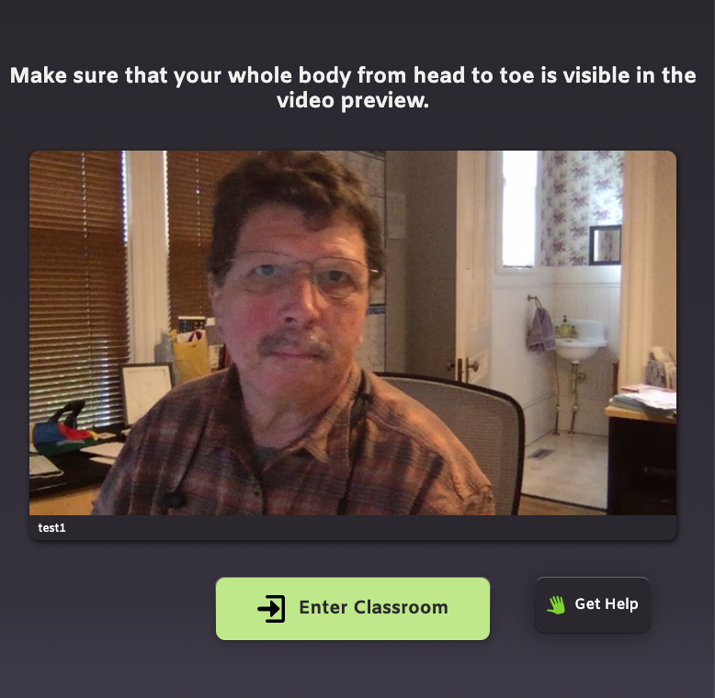

1. The instructor’s name should be below the image on the left (‘test1’ in this case). You should see your webcam preview. Notice text at the top. Click “Enter Classroom”
2. You should see the instructor’s view:  
     
   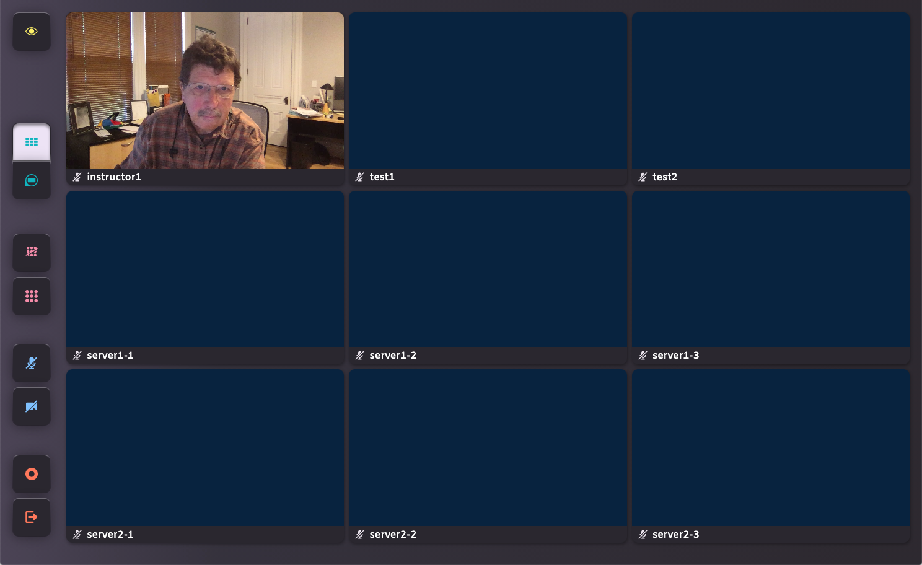
3. Notice buttons on the LEFT, everybody’s name below their assigned seats, and the instructor is always the upper-left position

## 

## Login as a participant.

1. You’ll follow a passwordless link with a ticket and a forceTime. The ticket matches your user, and the forceTime should be the same as for the instructor.
2. The participant’s landing page should show a single class:  
    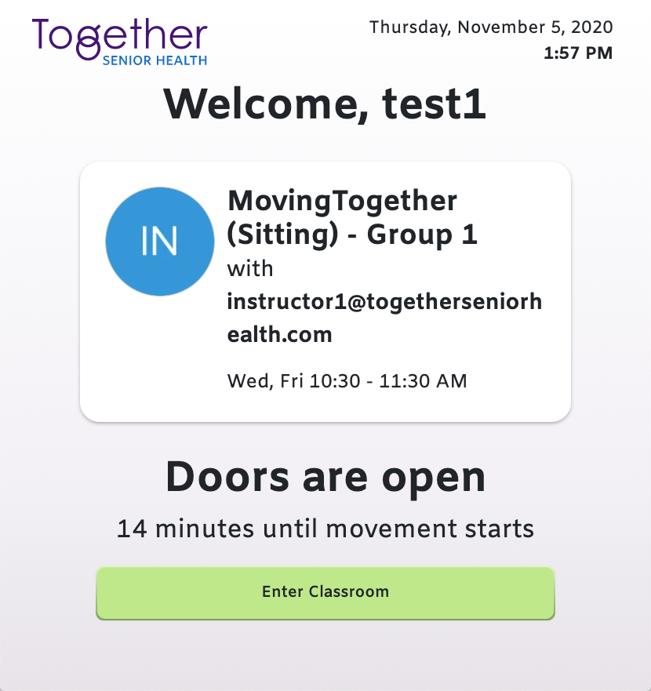
3. The pre-check page will be the same as the instructor’s, then you’ll go to the participant’s classroom page:  
     
   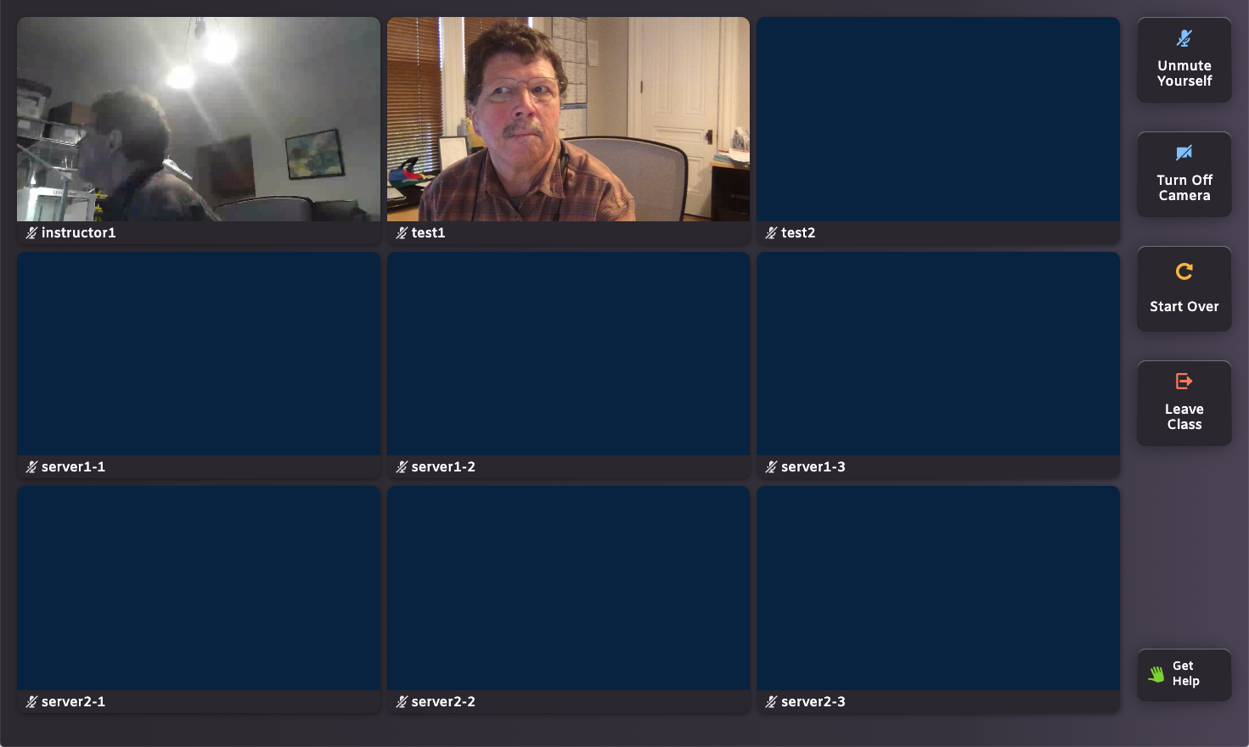
4. Notice instructor at upper-right, participant (that’s you!) next to it. There should be names for everybody, and everybody should show as muted. Notice controls at the right.
5. Go back to the instructor’s view, and find the leave button at the lower-left. Click it, and it will show a pop-up. Click “End”, and the instructor and the student should both leave the classroom:  
     
   